Engaging Communities in Each Research and Evaluation Step:
A Note-Taking Worksheet for the OPRE 2021 Methods Meeting
This worksheet is designed to help Office of Planning, Research, and Evaluation (OPRE) 2021 Methods Meeting participants build on the knowledge shared in meeting presentations. The worksheet includes a section to set your intention and a section to document opportunities and ideas for community engagement during each phase of the research and evaluation process. The worksheet provides additional space to note speakers, concepts, terms, and referenced resources that are particularly useful.

Intention Setting
We invite you to set your intention for the OPRE 2021 Methods Meeting. What do you hope to learn? How could you apply your learning to a current or upcoming project? Are you feeling reserved? Skeptical that this is a fad/trend? Identify that thought. Set your intention now and revisit it throughout the meeting.
Intention: Click or tap here to enter text.

Key Terms and Definitions
You can use this section to define key terms mentioned by speakers. We offer a few ideas for terms here. Add as many others as you would like.
Community –
Equity –
Community-based participatory research (CBPR) –
Youth-led participatory action research (YPAR) –
Community-Engaged Research (CER) –

Note-Taking and Brainstorming
Figure 1 details the phases of the research and evaluation process. Table 1 provides space for notes and brainstorming ideas for community engagement in each phase of the research and evaluation process.
Figure 1. The Research and Evaluation Process

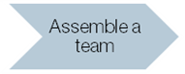
Table 1. Note-Taking and Brainstorming
Opportunities and Ideas for Community Engagement | Resources
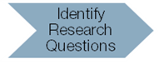
Opportunities and Ideas for Community Engagement | Resources
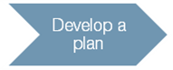
Opportunities and Ideas for Community Engagement | Resources
Opportunities and Ideas for Community Engagement | Resources
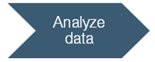
Opportunities and Ideas for Community Engagement | Resources
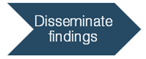
Opportunities and Ideas for Community Engagement | Resources

